What is a computer?
A computer is an electronic device that accepts data (input), processes it according to instructions, stores it, and produces useful results (output). It works in four basic steps:
Input → Processing → Storage → Output.

Hardware
Hardware is the physical parts of a computer that you can see and touch.
Main types:
- Input devices: keyboard, mouse, scanner, microphone, webcam
- Output devices: monitor, printer, speakers
- Processing unit: CPU (the "brain" of the computer)
- Storage devices: hard disk (HDD), SSD, pen drive, RAM, ROM
- Other parts: motherboard, power supply (SMPS), cabinet, cooling fan

Software
Software is the set of instructions or programs that tells the hardware what to do. You cannot touch it, but you can use it.
Main types:
- System software: Controls and manages the computer. Examples: Windows, Linux, macOS, Android, device drivers, utility programs.
- Application software: Helps users perform specific tasks. Examples: MS Word, Excel, Chrome, VLC Player, Photoshop.
- Programming software: Used to write programs. Examples: compilers, interpreters, code editors.

Simple comparison:
Hardware | Software
Physical, touchable | Logical, not touchable
Can be damaged physically | Can be corrupted by viruses or bugs
Example: CPU, RAM, keyboard | Example: Windows, MS Word
Needs software to work | Needs hardware to run

Components of a Motherboard
The motherboard is the main circuit board of the computer. It connects all hardware components and allows them to communicate with each other.
- CPU Socket: The slot where the processor is installed.
- RAM Slots (DIMM slots): Hold the memory modules (RAM) for temporary data storage.
- Chipset: Controls data flow between the CPU, RAM, storage and other devices. Usually split into the Northbridge (fast components) and Southbridge (slower I/O) in older boards.
- BIOS/UEFI Chip (ROM): Stores the startup instructions that run when you switch on the computer.
- CMOS Battery: A small coin cell battery that keeps the system clock and BIOS settings saved when power is off.
- Expansion Slots (PCI/PCIe): Used to add cards such as graphics card, sound card, or network card.
- SATA Connectors: Connect hard drives, SSDs and optical drives.
- M.2 Slot: Used for fast NVMe SSDs.
- Power Connectors: Bring power from the SMPS to the motherboard (24-pin ATX) and CPU (4/8-pin).
- I/O Ports (back panel): USB ports, HDMI/VGA, audio jacks, Ethernet (LAN) port, PS/2 ports.
- Front Panel Connectors: Connect the power button, reset button, LEDs and front USB/audio ports from the cabinet.
- CPU Fan Header: Powers the processor's cooling fan.
- Capacitors and Voltage Regulators: Store and regulate electrical power for stable operation.
- Heat Sinks: Metal parts that cool the chipset and power components.

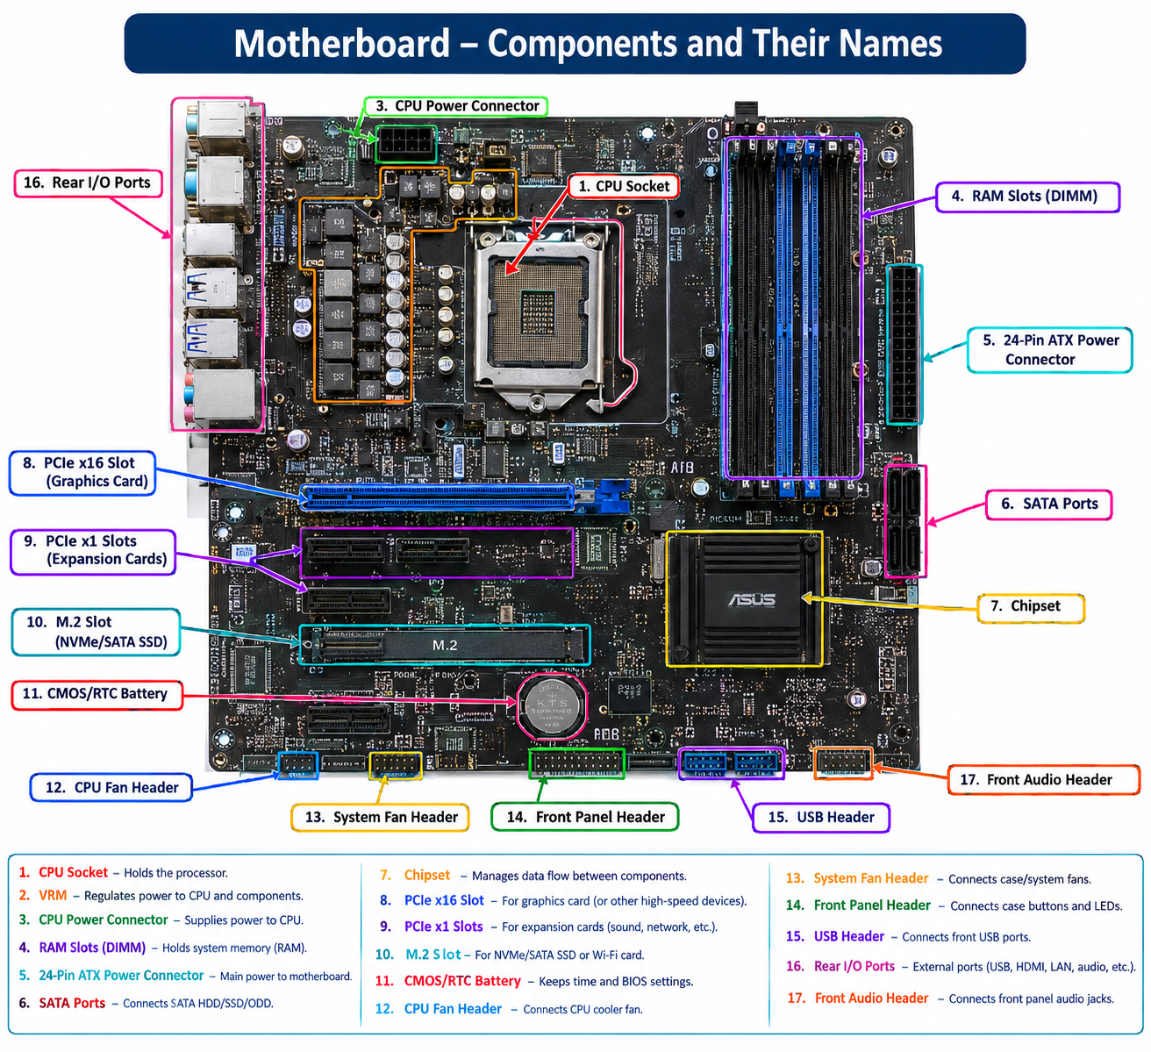

Processor (CPU)
What is a Processor?
The processor, also called the CPU (Central Processing Unit) or microprocessor, is the brain of the computer. It reads instructions from programs, performs calculations, makes decisions and controls all other hardware. It is a small chip made of billions of tiny transistors, installed in the CPU socket on the motherboard.
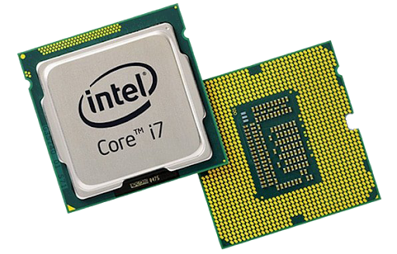
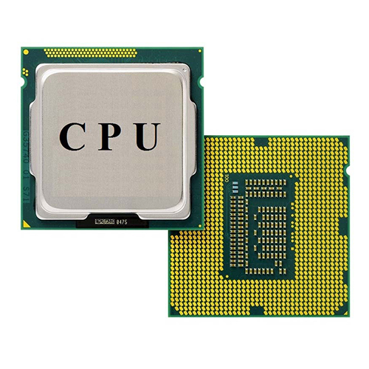
Main Parts of a CPU
1. ALU (Arithmetic Logic Unit)
Performs arithmetic operations (add, subtract, multiply, divide) and logical operations (AND, OR, NOT, comparisons like greater than or equal to).
2. CU (Control Unit)
Directs the whole computer. It fetches instructions from memory, decodes them, and tells the ALU, memory and I/O devices what to do. It does not process data itself.
3. Registers
Very small, extremely fast storage inside the CPU that holds data being processed right now. Important ones:
- Program Counter (PC): address of the next instruction
- Instruction Register (IR): the current instruction
- Accumulator (ACC): stores intermediate results
- Memory Address Register (MAR): address of the memory location to access
- Memory Data Register (MDR): data read from or written to memory
4. Cache Memory
Fast memory built into the CPU that stores frequently used data so the CPU does not wait for RAM.
- L1: smallest and fastest, one per core
- L2: larger, slightly slower
- L3: largest, shared between cores
5. Buses
Pathways that carry signals: the data bus (carries data), address bus (carries memory addresses) and control bus (carries control signals).

How a CPU Works: The Instruction Cycle
- Fetch: The CU gets the next instruction from RAM.
- Decode: The CU works out what the instruction means.
- Execute: The ALU or another unit carries out the instruction.
- Store: The result is written back to a register or RAM.
This repeats billions of times per second.
Important Specifications
Term | Meaning
Clock speed | Number of cycles per second, measured in GHz (3.5 GHz means 3.5 billion cycles per second).
Cores | Independent processing units in one chip (dual-core, quad-core, octa-core). More cores handle multitasking better.
Threads | Virtual tasks a core can handle. Hyper-Threading (Intel) or SMT (AMD) allows 2 threads per core.
Cache size | Total L1, L2 and L3 memory. More cache usually means better performance.
Word size / bit architecture | 32-bit or 64-bit: how much data the CPU processes at once. Most modern CPUs are 64-bit.
TDP | Thermal Design Power: heat produced, which decides cooling needs.
Socket type | The physical connector (e.g., LGA, AM4/AM5). It must match the motherboard.
Manufacturing process | Measured in nanometers (nm). Smaller means more efficient and cooler.

Types of Processors
By number of cores: single-core, dual-core, quad-core, hexa-core, octa-core and beyond.
By architecture:
- CISC (Complex Instruction Set Computing): many complex instructions, e.g., Intel and AMD x86.
- RISC (Reduced Instruction Set Computing): fewer, simpler instructions, e.g., ARM, used in smartphones.
By use:
- Desktop and laptop CPUs: Intel Core (i3/i5/i7/i9), AMD Ryzen
- Server CPUs: Intel Xeon, AMD EPYC
- Mobile processors: Qualcomm Snapdragon, Apple A/M series, MediaTek
Popular Processor Manufacturers
- Intel: Core i3, i5, i7, i9, Xeon
- AMD: Ryzen 3/5/7/9, EPYC
- Apple: M-series chips
- Qualcomm and MediaTek: mobile chips

Brief History
Generation | Technology
First | Vacuum tubes
Second | Transistors
Third | Integrated Circuits (ICs)
Fourth | Microprocessors (Intel 4004, 1971)
Fifth | AI and ULSI, multi-core processors

Related Processing Units
- GPU (Graphics Processing Unit): handles graphics and parallel tasks like gaming and AI.
- APU: AMD chip combining CPU and GPU.
- NPU: specialized for AI tasks.

Cooling and Care
Processors generate heat, so they need a heat sink, fan and thermal paste. Overheating causes slowdowns (thermal throttling) or shutdowns.

Computer Memory
What is Memory?
Memory is the part of a computer that stores data and instructions, either temporarily or permanently, so the processor can access them. Without memory, a computer could not hold programs, files or the results of calculations.
Memory is built from electronic circuits (semiconductor chips) or magnetic and optical media. It is measured in bytes.
Units of Memory
Unit | Size
1 Bit | Smallest unit (0 or 1)
1 Nibble | 4 bits
1 Byte | 8 bits
1 KB (Kilobyte) | 1,024 bytes
1 MB (Megabyte) | 1,024 KB
1 GB (Gigabyte) | 1,024 MB
1 TB (Terabyte) | 1,024 GB
1 PB (Petabyte) | 1,024 TB

Classification of Memory
Memory is divided into three main groups:
- Primary memory (main memory): directly accessed by the CPU
- Secondary memory (auxiliary storage): permanent, large storage
- Cache and registers: ultra-fast memory close to the CPU
1. Primary Memory
A. RAM (Random Access Memory)
RAM is the computer's working memory. It holds the programs and data currently in use. It is volatile, so everything is lost when power is switched off. It is called "random access" because any location can be read directly, without going through the earlier ones.
Types of RAM
SRAM (Static RAM)
- Uses flip-flops (transistors) to store each bit
- Very fast, needs no refreshing
- Expensive and takes more space
- Used for cache memory
DRAM (Dynamic RAM)
- Uses a capacitor and a transistor per bit
- Needs constant refreshing because capacitors leak charge
- Cheaper and holds more data
- Used as main RAM
Types of DRAM
- SDRAM: synchronized with the system clock
- DDR SDRAM: transfers data twice per clock cycle (DDR, DDR2, DDR3, DDR4, DDR5)
- GDDR: used in graphics cards
- LPDDR: low-power version for phones and laptops
DDR generations (approximate)
Type | Typical use
DDR3 | Older PCs and laptops
DDR4 | Widely used in recent PCs
DDR5 | Newer systems, faster and more efficient
RAM form factors
- DIMM: desktop computers
- SO-DIMM: laptops and mini PCs
B. ROM (Read Only Memory)
ROM stores permanent instructions such as the startup program (BIOS/UEFI). It is non-volatile, so data remains after power off. Normally it can only be read, not freely written.

Types of ROM
Type | Description
MROM (Masked ROM) | Programmed at the factory, cannot be changed
PROM | Programmable once by the user
EPROM | Erasable using ultraviolet light and reprogrammable
EEPROM | Erased and rewritten electrically
Flash memory | A type of EEPROM, erased in blocks; used in BIOS chips, SSDs, USB drives
RAM vs ROM
Feature | RAM | ROM
Full form | Random Access Memory | Read Only Memory
Volatility | Volatile | Non-volatile
Read/Write | Both | Mostly read only
Speed | Faster | Slower
Use | Running programs and data | Startup instructions (BIOS)
Cost per GB | Higher | Lower

2. Cache Memory
Cache is a small, extremely fast memory placed between the CPU and RAM. It stores frequently used data and instructions, so the CPU does not have to wait for slower RAM.
- L1 cache: inside each core, smallest and fastest
- L2 cache: larger, slightly slower, per core or shared
- L3 cache: largest, shared by all cores
Cache hit: the CPU finds the data in cache (fast).
Cache miss: the data is not in cache, so it is fetched from RAM (slower).

3. Registers
Registers are the fastest and smallest memory, inside the CPU itself. They hold the data and instructions being processed at that exact moment, such as the program counter and accumulator.

4. Secondary Memory (Storage)
Secondary memory is non-volatile, with large capacity, used to store the OS, software and files permanently. The CPU cannot access it directly; data is first loaded into RAM.
Types
Magnetic storage
- HDD (Hard Disk Drive): spinning platters and a moving read/write head. Cheap and high capacity, but slower and fragile.
- Magnetic tape: used for backups and archives.
Solid-state storage
- SSD (Solid State Drive): uses flash memory with no moving parts. Faster, quieter and more durable. Types include SATA SSD and NVMe SSD (M.2, much faster).
- Pen drive (USB flash drive)
- Memory cards (SD, microSD)
Optical storage
- CD (~700 MB), DVD (~4.7 GB), Blu-ray (25 GB or more)
HDD vs SSD
Feature | HDD | SSD
Technology | Magnetic spinning disk | Flash memory chips
Speed | Slower | Much faster
Noise | Audible | Silent
Durability | Sensitive to shock | More durable
Power use | Higher | Lower
Price per GB | Cheaper | More expensive

Memory Hierarchy
Memory is arranged by speed, cost and size:
Registers → Cache (L1, L2, L3) → RAM → SSD/HDD → Optical/Tape
- Going up: faster, more expensive, smaller capacity
- Going down: slower, cheaper, larger capacity
This design gives good performance at reasonable cost.

Virtual Memory
When RAM becomes full, the operating system uses part of the hard disk or SSD as extra "RAM". This is called virtual memory (page file in Windows, swap space in Linux). It lets the computer run more programs, but it is much slower than real RAM.

Volatile vs Non-Volatile Memory
Volatile | Non-volatile
Loses data without power | Keeps data without power
RAM, cache, registers | ROM, HDD, SSD, USB drives

Important Memory Specifications
- Capacity: how much data it holds (e.g., 8 GB, 16 GB)
- Speed or frequency: in MHz or MT/s (e.g., DDR4-3200)
- Latency: the delay before data is delivered (CAS latency)
- Bandwidth: how much data moves per second
- Dual-channel: using two RAM sticks together for better speed

